Friday November 16th 2012

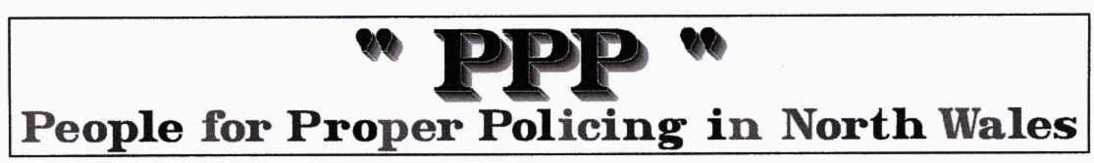
Winston Roddick elected as North Wales police and crime commissioner

Full story at http://www.bbc.co.uk/news/uk-wales-20349552
The QC began his career as a police constable in Liverpool before becoming a barrister and has been a crown court recorder.
After his victory, Mr Roddick said he was aware of the "big challenge ahead".
"I hope I'm up to the challenge and I hope that I will get the assistance from the interested groups that has been promised,"
"But I make a personal commitment that I will commit myself to these challenges and I will do my utmost to score the points I said need scoring in giving the people of north Wales the police service they're entitled to."
In his campaign, Mr Roddick said the police commissioner needed to act independently of political interference.
He beat Labour's Tal Michael, the former chief executive of North Wales Police Authority, whose father is standing for election for the same post in the South Wales force area.
The PPP comments ….. We supported Richard Hibbs for this position because he was proactive in setting out his stall and we liked his independence both in thought and background and politics. We were impressed with Winston Roddick’s campaign and only got to know him from this exposure very close to the election.
The aims and objectives of the PPP are almost unchanged from our foundation over 8 years ago and we feel that Winston Roddick’s objectives have much in common. We can work with him as he defines his organization and action plan. In the BBC coverage only 10 minutes ago, they were interviewing an American who stated the obvious that all the new commissioners have the job of working co-operatively with their Chiefs and force members to meet our expectations and their responsibilities. Not a single UK Politician or commentator (or candidate clearly) had stated this obvious reality. There has been far too much emphasis on hiring and firing and holding to account. Such bombast comes from the likes of Boris Johnson who has yet to get anywhere near that level of understanding with the Met and the results are pretty poor as a consequence.

